Computer Networking

Assignment 3

Deadline Dec. 9, 2024

**Submission format: submit your solution in a single file to blackboard under Assignment Section, choose whatever format you like (jpg, pdf, word) as long as it is clear enough for grading, compress into a single .zip file if there are multiple files). Comment your name and student number in the submission**

Problem 1: Switching Fabrics (10 points)

Consider the switch shown below. Suppose that all datagrams have the same fixed length, that the switch operates in a slotted, synchronous manner, and that in one time slot a datagram can be transferred from an input port to an output port. The switch fabric is a crossbar so that at most one datagram can be transferred to a given output port in a time slot, but different output ports can receive datagrams from different input ports in a single time slot. What is the minimal number of time slots needed to transfer the packets shown from input ports to their output ports, assuming any input queue scheduling order you want (i.e., it need not have HOL blocking)? What is the largest number of slots needed, assuming the worst-case scheduling order you want (i.e., it need not have HOL blocking)? What is the largest number of slots needed, assuming the worst-case scheduling order you can devise, assuming that a non-empty input queue is never idle?

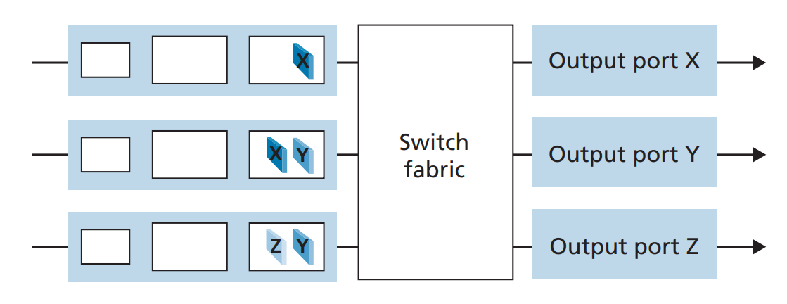

Problem 2: Packet Scheduling (10 points)

Suppose that the WEQ scheduling policy is applied to a buffer that supports three classes, and suppose the weights are 0.5, 0.25, and 0.25 for the three classes.

1. Suppose that each class has a large number of packets in the buffer. In what sequence might the three classes be served in order to achieve the WFQ weights? (For round robin scheduling, a natural sequence is 123123123 . . .).
2. Suppose that classes 1 and 2 have a large number of packets in the buffer, and there are no class 3 packets in the buffer. In what sequence might the three classes be served in to achieve the WFQ weights?

Problem 3: IP Addressing (15 points)

Consider a datagram network using 32-bit host addresses. Suppose a router has four links, numbered 0 through 3, and packets are to be forwarded to the link interfaces as follows:

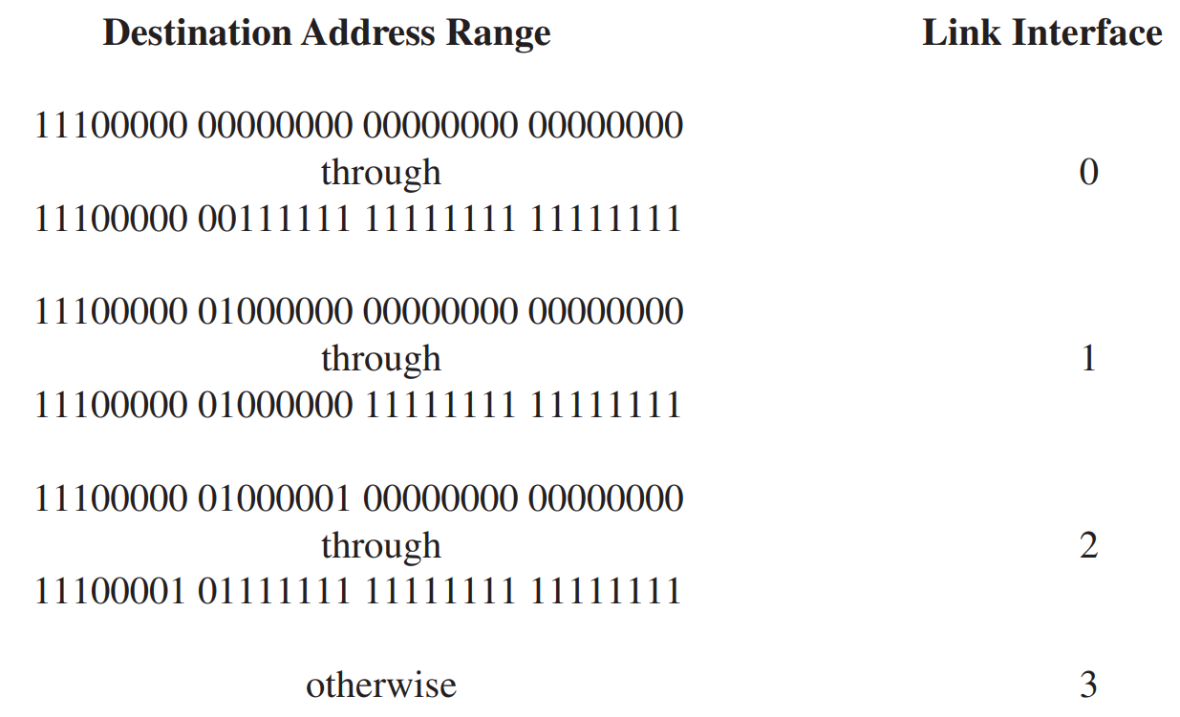

(1) Provide a forwarding table that has five entries, uses longest prefix matching, and forwards packets to the correct link interfaces.

(2) Describe how your forwarding table determines the appropriate link interface for datagrams with destination addresses:

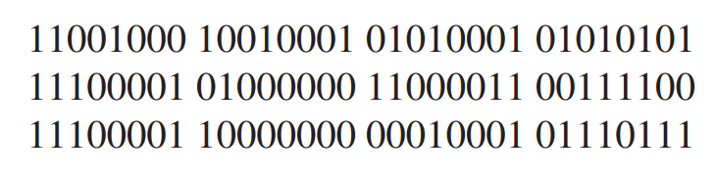

(3) Provide a forwarding table (using longest prefix matching). Rewrite this forwarding table using the a.b.c.d/x notation instead of the binary string notation.

Problem 4: Subnet (10 points)

Consider the topology shown in Figure 1. Denote the three subnets with hosts (starting clockwise at 12:00) as Networks A, B, and C. Denote the subnets without hosts as Networks D, E, and F.

1. Assign network addresses to each of these six subnets, with the following constraints: All addresses must be allocated from 214.97.254/23; Subnet A should have enough addresses to support 250 interfaces; Subnet B should have enough addresses to support 120 interfaces; and Subnet C should have enough addresses to support 120 interfaces. Of course, subnets D, E and F should each be able to support two interfaces. For each subnet, the assignment should take the form a.b.c.d/x or a.b.c.d/x – e.f.g.h/y.
2. Using your answer to part (a), provide the forwarding tables (using longest prefix matching) for each of the three routers.

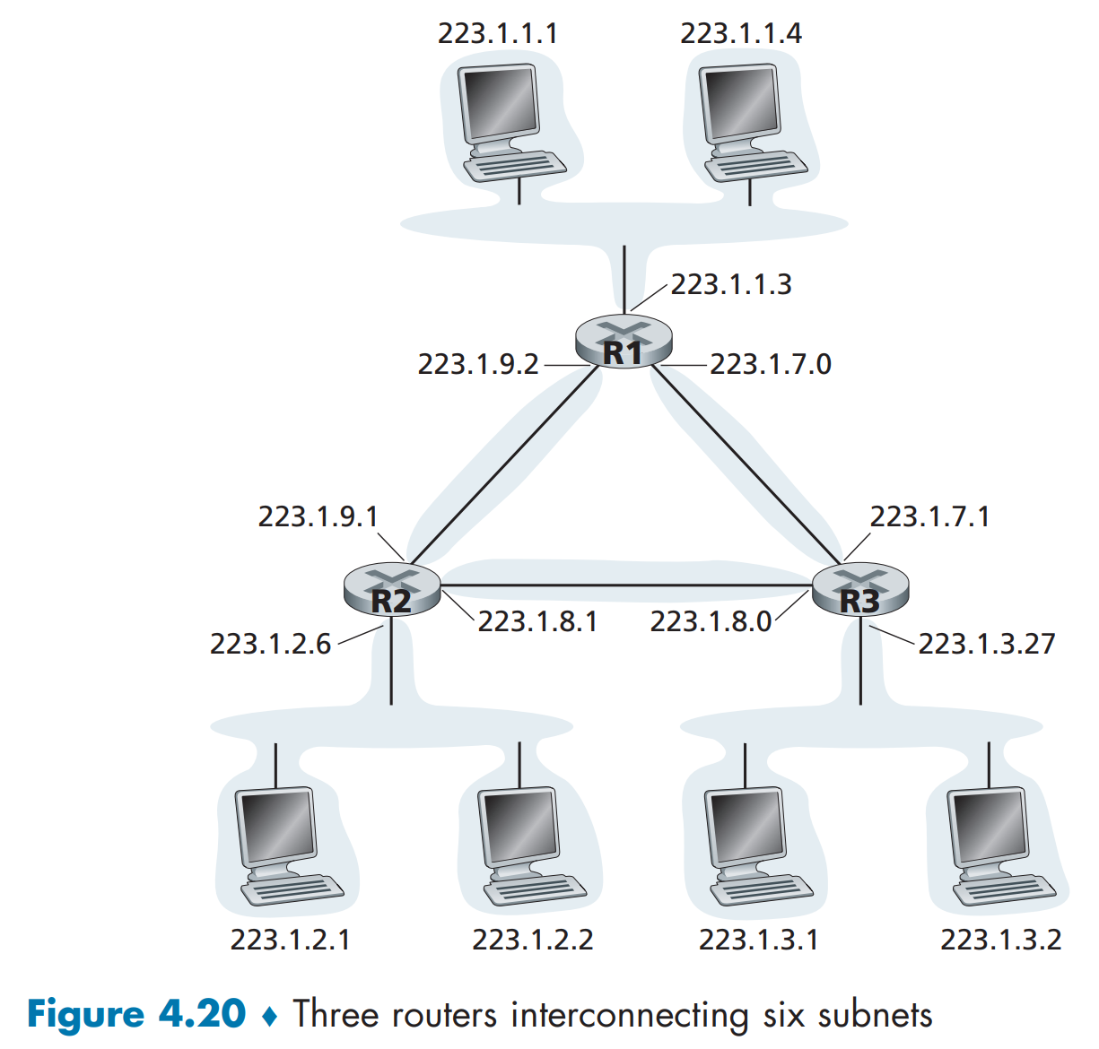

Figure 1 Three routers interconnecting six subnets.

Problem 5: SDN (15 points)

Consider the SDN OpenFlow network shown in Figure 2. Suppose that the desired forwarding behavior for datagrams arriving at s2 is as follows:

1. any datagrams arriving on input port 1 from hosts h5 or h6 that are destined to hosts h1 or h2 should be forwarded over output port 2;
2. any datagrams arriving on input port 2 from hosts h1 or h2 that are destined to hosts h5 or h6 should be forwarded over output port 1;
3. any arriving datagrams on input ports 1 or 2 and destined to hosts h3 or h4  
   should be delivered to the host specified;
4. hosts h3 and h4 should be able to send datagrams to each other.

Specify the flow table entries in s2 that implement this forwarding behavior.

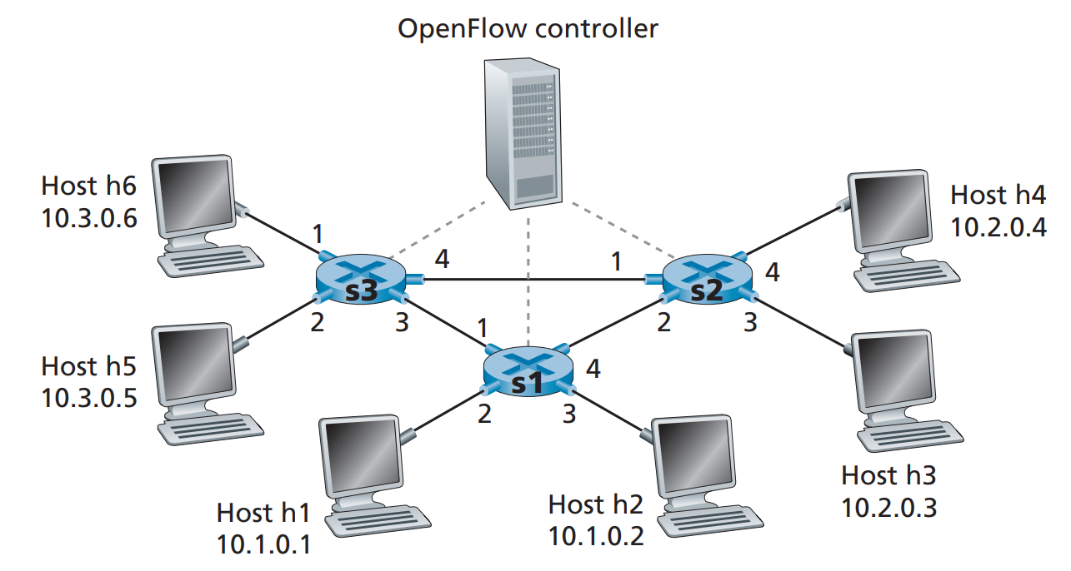

Figure 2 OpenFlow match-plus-action network with three packet switches, 6 hosts, and an OpenFlow controller

Problem 6: Link State Routing (10 points)

Consider the following network. With the indicated link costs, use Dijkstra’s shortest-path algorithm to compute the shortest path from x to all network nodes. Show how the algorithm works by computing a table similar to Table 1.

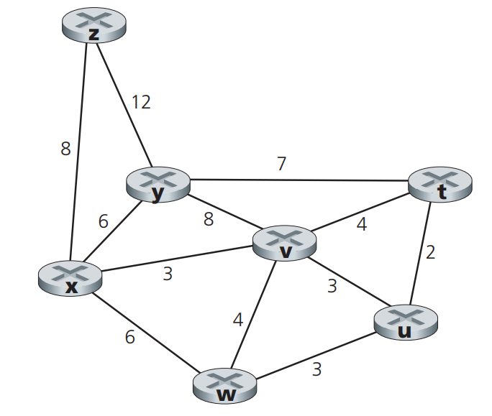

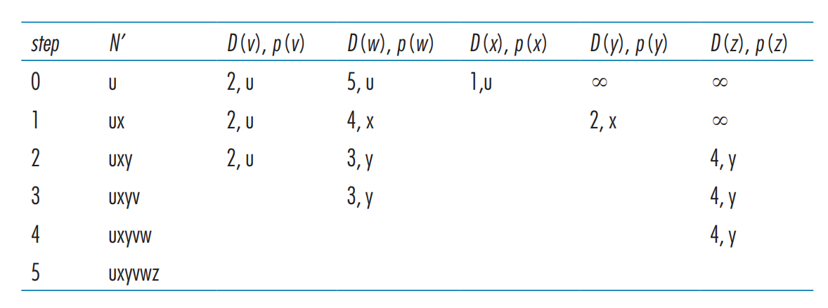

Table 1. Running the link-state algorithm

Problem 7: Distance Vector Routing (10 points)

Consider the network fragment shown below. x has only two attached neighbors, w and y. w has a minimum-cost path to destination u (not shown) of 5, and y has a minimum-cost path to u of 6. The complete paths from w and yto u (and between w and y) are not shown. All link costs in the network have strictly positive integer values.

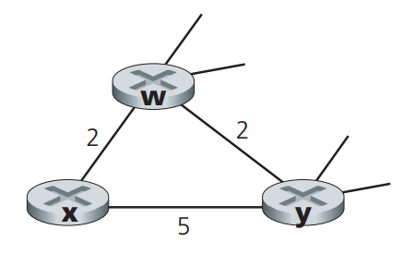

1. Give x’s distance vector for destinations w, y, and u.
2. Give a link-cost change for either c(x,w) or c(x,y) such that x will inform its neighbors of a new minimum-cost path to u as a result of executing the distance-vector algorithm.
3. Give a link-cost change for either c(x,w) or c(x,y) such that x will notinform its neighbors of a new minimum-cost path to u as a result of executing the distance-vector algorithm.

Problem 8: Border Gateway Protocol (20 points)

Consider the network shown below. Suppose AS3 and AS2 are running OSPF for their intra-AS routing protocol. Suppose AS1 and AS4 are running RIP for their intra-AS routing protocol. Suppose eBGP and iBGP are used for the inter-AS routing protocol. Initially suppose there is no physical link between AS2 and AS4.

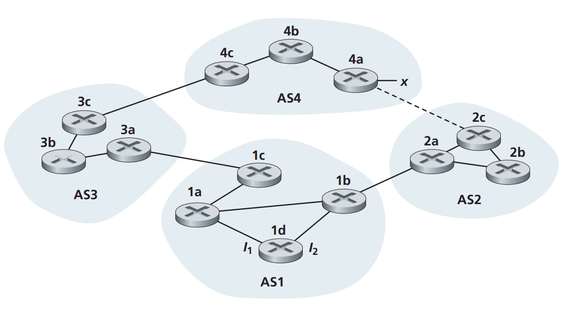

1. Router 3c learns about prefix x from which routing protocol: OSPF, RIP,  
   eBGP, or iBGP?
2. Router 3a learns about x from which routing protocol?
3. Router 1c learns about x from which routing protocol?
4. Router 1d learns about x from which routing protocol?

Referring to the previous problem, once router 1d learns about x it will put an entry (x, I) in its forwarding table.

1. Will I be equal to I1 or I2 for this entry? Explain why in one sentence.
2. Now suppose that there is a physical link between AS2 and AS4, shown by the dotted line. Suppose router 1d learns that x is accessible via AS2 as well as via AS3. Will I be set to I1 or I2? Explain why in one sentence.
3. Now suppose there is another AS, called AS5, which lies on the path between AS2 and AS4 (not shown in diagram). Suppose router 1d learns that x is accessible via AS2 AS5 AS4 as well as via AS3 AS4. Will I be set to I1 or I2? Explain why in one sentence.